**PyQt5**

**运行截图**

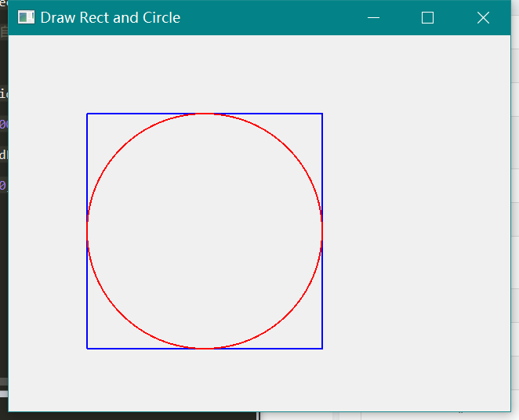

**源程序**

**import math**

**import sys, random**

**from PyQt5.QtWidgets import QApplication,QWidget**

**from PyQt5.QtCore import Qt**

**from PyQt5.QtGui import QPainter, QPen,QColor, QBrush**

**class UI(QWidget):**

**def __init__(self):**

**super().__init__()**

**self.initUI() # 界面绘制交给InitUi方法**

**def initUI(self):**

**self.desktop = QApplication.desktop()**

**self.setWindowTitle("Draw Rect and Circle")**

**#获取显示器分辨率大小**

**self.screenRect = self.desktop.screenGeometry()**

**self.height = self.screenRect.height()**

**self.width = self.screenRect.width()**

**# 显示窗口**

**def paintEvent(self, e): #自动执行的绘画事件**

**qp =QPainter()**

**qp.begin(self)**

**#矩形**

**pen=QPen(Qt.blue,2,Qt.SolidLine)**

**qp.setPen(pen)**

**qp.drawRect(100,100,300,300)**

**#圆形**

**pen=QPen(Qt.red,2,Qt.SolidLine)**

**qp.setPen(pen)**

**qp.drawArc(100,100,300,300,0,10000)**

**qp.end()**

**if __name__ == '__main__':**

**# 创建应用程序和对象**

**app = QApplication(sys.argv)**

**ex = UI()**

**ex.show()**

**sys.exit(app.exec_())**

**流水灯**

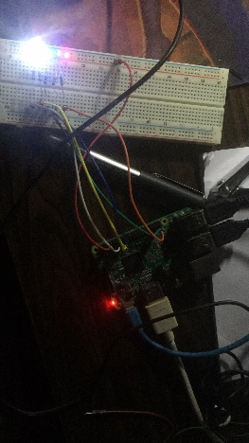

**效果:**

**每隔0.5秒按序点亮一盏灯，全部点亮后每隔0.5秒熄灭一盏**

**源代码：**

**import RPi.GPIO as GPIO**

**import time**

**pins = [11,13,15,35,37] #选择管脚**

**def setup():**

**GPIO.setmode(GPIO.BOARD) #选择编码，应该先选模式再选孔**

**for pin in pins:**

**GPIO.setup(pin, GPIO.OUT) #初始化管脚**

**GPIO.output(pin, GPIO.LOW) #设置管脚状态为低电频**

**def loop():**

**while True: #遍历各个管脚，每隔0.5秒按序点亮一盏灯，全部点亮后每隔0.5秒熄灭一盏**

**for pin in pins:**

**GPIO.output(pin, GPIO.HIGH)**

**time.sleep(0.5)**

**for pin in pins[::-1]:#反向遍历的操作**

**GPIO.output(pin, GPIO.LOW)**

**time.sleep(0.5)**

**def destroy(): #关闭函数**

**for pin in pins:**

**GPIO.output(pin, GPIO.LOW) #设置各个管脚为低电频**

**GPIO.setup(pin, GPIO.IN) #初始化管脚**

**setup()**

**try:**

**loop()**

**except KeyboardInterrupt: #按下键盘产生中断**

**destroy()**

**三色灯1：**

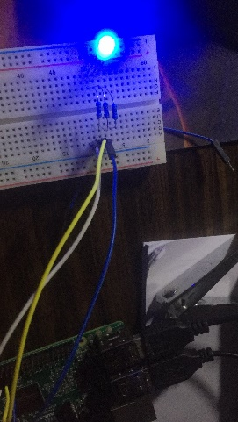

**效果:**

**每隔0.5秒按红绿蓝切换颜色**

**源代码：**

**import RPi.GPIO as GPIO**

**import time**

**pins = [11,13,15] #选择管脚**

**def setup():**

**GPIO.setmode(GPIO.BOARD) #选择编码，应该先选模式再选孔**

**for pin in pins:**

**GPIO.setup(pin, GPIO.OUT) #初始化管脚**

**GPIO.output(pin, GPIO.HIGH) #设置管脚状态为高电频**

**def loop():**

**while True:**

**for pin in pins:**

**GPIO.output(pin, GPIO.LOW)**

**time.sleep(0.5)**

**GPIO.output(pin, GPIO.HIGH)**

**def destroy(): #关闭函数**

**for pin in pins:**

**GPIO.output(pin, GPIO.LOW) #设置各个管脚为低电频**

**GPIO.setup(pin, GPIO.IN) #初始化管脚**

**setup()**

**try:**

**loop()**

**except KeyboardInterrupt: #按下键盘产生中断**

**destroy()**

**三色灯2：**

**效果:**

**七种颜色切换 每隔0.5秒按红、黄、白、青、蓝、绿、粉红 切换颜色**

**源代码：**

**import RPi.GPIO as GPIO**

**import time**

**pins = [11,13,15]**

**def setup():**

**GPIO.setmode(GPIO.BOARD)**

**for pin in pins:**

**GPIO.setup(pin, GPIO.OUT)**

**GPIO.output(pin, GPIO.HIGH)**

**def loop():**

**while True:**

**for pin in pins: #分别点亮RGB但不熄灭，呈现红、黄、白**

**GPIO.output(pin, GPIO.LOW)**

**time.sleep(0.5)**

**for pin in pins[:2]: #分别熄灭RG，呈现青、蓝**

**GPIO.output(pin, GPIO.HIGH)**

**time.sleep(0.5)**

**GPIO.output(pins[0], GPIO.HIGH) #同时熄灭RB，呈现绿**

**GPIO.output(pins[2], GPIO.HIGH)**

**GPIO.output(pins[1], GPIO.LOW)**

**time.sleep(0.5)**

**GPIO.output(pins[1], GPIO.HIGH) #熄灭G，呈现粉红**

**GPIO.output(pins[0], GPIO.LOW)**

**GPIO.output(pins[2], GPIO.LOW)**

**time.sleep(0.5)**

**GPIO.output(pins[2], GPIO.HIGH) #调回红色，照应上面循环的开始**

**def destroy():**

**for pin in pins:**

**GPIO.output(pin, GPIO.LOW)**

**GPIO.setup(pin, GPIO.IN)**

**setup()**

**try:**

**loop()**

**except KeyboardInterrupt:**

**destroy()**